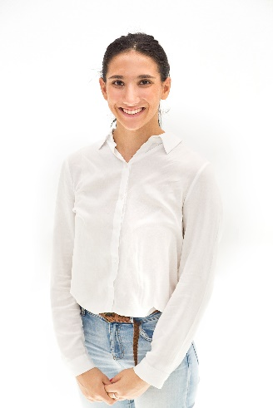 | Annelise Sarikas
Date of birth  Contact number  Email address  LinkedIn profile | 15 May 1999  (+61) 450 150 599  asarikas@live.com.au  www.linkedin.com/in/annelisesarikas
Education | UNSW Bachelor of Food Science and Technology - Third Year Student.  Wenona Independent Girls School North Sydney - 2017 Graduate.
Achievements | Bronze Duke of Edinburgh 2014  Silver Duke of Edinburgh 2015  Gold Duke of Edinburgh 2017
Work experience  Internship | Yaffa Media, Food and Drink business (2019): 1- week work experience  Coca-Cola Amatil (2015): 1- week shadowing the quality control manager.  Skills:  - Oral Communication Skills with adults  Practical Learning experience  Skills:  - Independent research  - Independent article writing  - Oral Communication Skills  The Australian Institute of Food Science and Technology (2019): 6- week internship  Skills:  - Computer Skills (using Excel, Nab Transact, Sugar and editing websites)  - Oral Communication via telephone skills  - Written communication  - Social Media (Facebook, Twitter, Linked in)  - Problem Solving  - Teamwork  - Independent working
Casual work  Part time work | Seed Heritage Mosman: November 2017+  Skills:  - Computer skills (using WTPOS)  - EFTPOS use  - Face-to-face selling  Australian Institute of Food Science and Technology (AIFST)- Membership services officer: 2020+  Neutral Bay Pharmacy: 2013 – 2015  Skills:  - Computer skills (Using Fred)  - Oral communication skills  Simmone Logue, Fine Foods Cammeray: December 2015- February 2017  Skills:  - Waitressing skills  - Verbal Communication  - Punctuality in delivering Food  - EFTPOS Skills
Community service  2020  2014 -2015  2011-2015  2016-2017 | UNSW Science Peer Mentor  Volunteer at St Johns Child Care Neutral Bay  Flute Busking at Christmas time and donating funds to a Kenyan School.  Wrap with love program, knitting for those less privileged
References | References Upon Request

